Draftwork Quickstart for Instructors
Set up an assignment, open the submissions and talk with your students
You need: Chrome or Microsoft Edge, and a course site where you can make a dropbox and download all submissions as a zip file.
CAUTION: Do not use a flag as evidence on its own. A flag is a reason to ask the student a question. Follow the academic integrity policy of your institution.

1. Before the assignment
- Open Draftwork. Click Open assignments.
- Type the Title, the Due date and the Course dropbox link. Click Create.
- When the browser asks, select a backup folder, for example in your OneDrive.
- Click Instructions for students. Click Copy instructions.
- Paste the instructions into the assignment in your course site.
- Set the dropbox to accept .draftwork files, or all file types.

2. After students upload
- In your course site, download all submissions as one zip file.
- In Draftwork, click Submissions. Drag the zip file onto the page.
- In Sort, select Most serious first.
- Click a submission. Read the summary at the top and the flags.
- Click a moment button to see that moment in the replay.

Colour | Meaning | What to do
Red: Major flags | A major flag, or three or more flags. | Talk with the student.
Amber: Minor flags | One or two minor flags. | Ask a short question if necessary.
Green: No flags | Nothing unusual. | Read some of these too.

NOTE: File unaltered shows only that the file was not changed. It does not show who wrote the work.

3. Talk with the student
- In Questions to ask, select two or three questions.
- Ask the questions openly. Do not tell the student what was flagged before the student answers.
- Type each answer. Select the outcome.
- In each flag, select your decision in Review.
- Optional: click Print summary to keep a record.

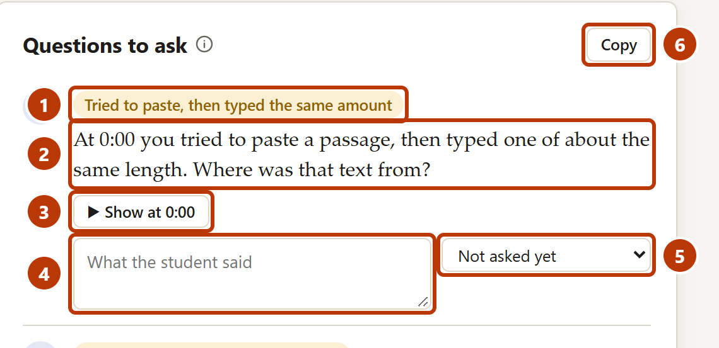
Figure 1. Questions to ask
Number | Item | What it is for
1 | Label | The flag or moment that the question is about.
2 | Question | A question to read to the student.
3 | Show at | Shows the moment in the replay.
4 | Answer box | Type what the student said.
5 | Outcome | Explained convincingly, Answer unclear or Needs follow-up.
6 | Copy | Copies the questions as a list.

For full instructions, see the Draftwork Instructor Guide, or click Guide in Draftwork.

